SUMMARY OF FLOODPLAIN IMPACTS

D08 Culvert Repair FY2023 – PID 100799

Date: | 7/09/2021
Project ID: |  | D08 Culvert Repair FY2023 – PID 100799
Flood Plain Affected: |  |  | Tributary to Four Mile Creek – Flood Zone A

Description of Project:
Rehabilitate larger bridge size corrugated metal pipes including BUT-122-0835 (SR 122 over Crawford St in Middletown), BUT-129-1958 (SR 129 over Mill Creek), and PRE-122-0205 (which carries SR 122 over a Tributary of Four Mile Creek).

Why must this project be located in the Floodplain?
Because the culvert in question (PRE-122-0205) has been constructed within the floodplain in order to safely carry traffic on SR 122 over the Tributary of Four Mile Creek, and this project is rehabilitating the metal culvert by repairing of rusted areas.

What alternative sites were considered, if any?
None, since the culvert is already in place and this project is not reconstructing a new culvert, just working on the one present.

Were any mitigation measures utilized on this project? If so, please describe.
No, since the scope of work is minimal and poses no risk to the floodplain.

To the best of my knowledge, this project has complied with all applicable Local, State, and Federal Floodplain protection standards.

Print Name: |  |  |  | Maxwell L. Bailey, P.E.
Signature: |  |  | 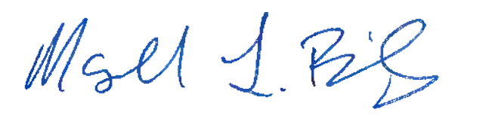
Title: |  | Project Manager

16

